2023 Year 6 Commemorative Senior Shirt

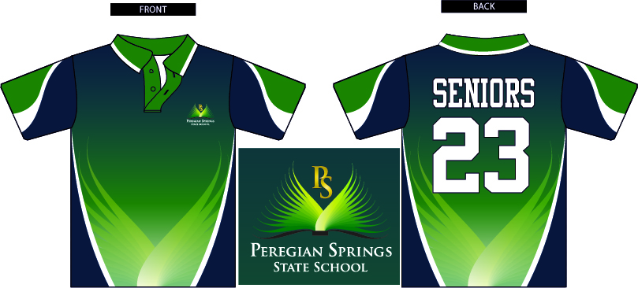

Dear Parents/Carers

All students going into Year 6 will have the opportunity to purchase a commemorative Senior shirt to celebrate their final year in Primary School.

This special polo shirt has been designed with a distinctive pattern to reflect the Sunshine Coast but also in the school colours. The back of the shirt will display ‘Seniors 23’

You are able to purchase a Senior shirt on Qkr!. If you haven’t already please download and register your and your child/children’s details. Please ensure the Yr level and class are correct, then click on Senior Shirt and select a size. This is the quickest and easiest way to purchase and pay for a range of items in the app.

The app will re-open for Senior shirt orders on Monday 12 September and close on Friday 7 October

Please make sure your child has tried on the sample shirts that are available in the Uniform Shop before placing an order. The Senior shirts are different sizing to the regular School polo and once an order is placed, it can not be exchanged or refunded.

Order cut off is 3:00pm Friday 7 October
This is the first order to be placed for Senior 2023 shirts, there will be a second order placed in Term 1 2023, to accommodate for new and existing students wishing to purchase a Senior shirt.

The cut off for ordering and making payment is 3:00pm Friday 7 October No late orders will be accepted.
- Cost of shirt: $45.00
- Last day to order online on Qkr, returning order forms & payment: 3:00pm Friday 7 October 2022
- Approximate delivery date for shirts will be 6-8 weeks.

If you do not wish to order online then please complete the form below and make payment to the Uniform Shop or the Office within the time frame allocated

Payment can be made by Eftpos.

Regards
Sally Houghton
Uniform Convenor

Please complete this form if paying via Eftpos:

Student’s Name | Class | Quantity | Size | Cost | Date paid at Office
 |  |  |  | $45.00

Parent or Carer’s signature _____________________________ Date _______________________

Please note that the Senior shirts are different sizing to the regular School polo shirt.
There are sample shirts available to try on in the Uniform Shop, please do so before placing an order. No exchanges or refunds can be made for wrong sizes, as the shirts are made to order.

Thank you,
Sally.

